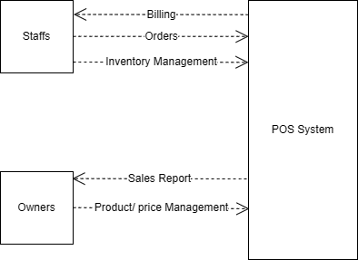

• Staff (Cashier/Server):

Inputs: Takes orders, processes payments, updates inventory.Outputs: Receives transaction confirmations and receipts.

• Owner:

Inputs: Views sales reports, manages menu items, pricing, and inventory.

• POS System (Process):

Acts as the central process handling orders, inventory management, billing, and report generation